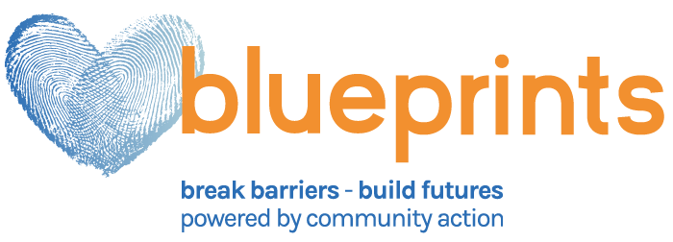
Anastasia Barr
Communications Manager
Blueprints and RACG Home Ownership Partnership
724-225-9550 x634
abarr@myblueprints.org

FOR IMMEDIATE RELEASE

GREENE COUNTY REDEVELOPMENT AUTHORITY & BLUEPRINTS PARTNER TO PROMOTE AFFORDABLE HOME OWNERSHIP OPPORTUNITIES

Waynesburg, PA— The Redevelopment Authority of the County of Greene (RACG) and Blueprints are collaborating to promote affordable home purchase opportunities.
The RACG is currently rehabilitating 10 homes located within the communities of Clarksville, Crucible and Nemacolin that will all be ready for sale throughout 2020. Home prices are anticipated to range between $50,000 to $70,000, per home.
The homes will be available to residents with low-and-moderate incomes who qualify and participate in free HUD-Certified home purchase services available through Blueprints’ Home Ownership Center.
Funding is also available through the collaboration to help residents secure financial assistance for down payments.
The RACG obtains blighted and underutilized property in Greene County to rehabilitate or build new homes to ensure homeownership is in reach for all residents. The mission of the RACG is to assist the Greene County community with economic development, community revitalization, affordable housing initiatives and home ownership opportunities.
Blueprints’ Home Ownership Center assists area residents to determine a mortgage they can afford, review credit scores, create plans to repair credit scores, discuss options for down payment assistance and explore pre-qualification for suitable loan programs. For homeowners facing foreclosure, mitigation options are pursued.
For additional information regarding the homes that will be available for purchase through the RACG, please contact Dave Calvario by telephone at 724.852.5306 or by email at dcalvario@co.greene.pa.us
For additional information regarding Blueprints’ Home Ownership Center, please contact Mallory McHugh by telephone at 724.225.9550 ext. 486 or by email at mmchugh@myblueprints.org

About Blueprints
Blueprints is a change agency that shapes futures by equipping and educating people to improve their lives. Independence is gained when we break barriers and build futures.

Powered by community action, we are proud of our legacy: strengthening and serving our community. We stand committed to the mission of the community action movement. We take pride in our membership to the network and champion our shared vision.

Blueprints, formerly Community Action Southwest, is a non-profit organization that has been serving our area since 1965. Founded by a group of community leaders, the initial focus of the agency was to mobilize public and private resources to deal with the causes of poverty, not just its impact.

More than 50 years later, our mission remains much the same. We are still committed to solving poverty, but we aim to help our clients achieve stability. By focusing on the mind, home, health and wallet, we help and encourage people to meet their future needs independently.

Today, Blueprints operates more than 50 programs serving more than 20,000 people annually in Washington and Greene counties of Pennsylvania and throughout West Virginia. Blueprints has an annual budget of nearly $23 million, and employs more than 350 individuals.

We serve our neighbors from cradle to gray. We provide assistance at all income levels. We co-design solutions that encourage self-made stability.

About Blueprints Home Ownership Center

This program helps people with low credit scores who would like to purchase a home. It’s also for people who are intimidated by the home-ownership process, or who aren’t sure which steps to take regarding a home purchase. And it helps people who are facing a foreclosure or are unable to make their current mortgage payment.

- One of our HUD-certified Housing Counselors will help you obtain and review your credit score and determine (if needed) how those scores can be improved.

- We’ll also help you determine the mortgage payment you can afford and review options for down payment assistance.

- If you’re a homeowner struggling to pay your mortgage, we’ll help you begin the process to refinance (if needed) and help you enroll in programs designed to prevent foreclosure.

For additional information regarding Blueprints’ Home Ownership Center, please contact Mallory McHugh by telephone at 724.225.9550 ext. 486 or by email at mmchugh@myblueprints.org or visit https://myblueprints.org/services/home/home-ownership-center/

About Greene County Redevelopment Authority of Greene

The Redevelopment Authority of the County of Greene (RACG) is a statutory agency of the Commonwealth which operates within Greene County, Pennsylvania. RACG was activated to increase affordable housing and home ownership opportunities, redevelop blighted areas and, in conjunction with other County, State and Federal entities, provide for community revitalization in Greene County. The Redevelopment Authority operates under the Urban Redevelopment Law of 1945 as well as the Redevelopment Cooperation Law of 1945.
"To assist the Greene County community with economic development,
community revitalization, affordable housing initiatives,
and home ownership opportunities"

For additional information regarding the homes that will be available for purchase through the RACG, please contact Dave Calvario by telephone at 724.852.5306 or by email at dcalvario@co.greene.pa.us

Website: https://www.co.greene.pa.us/Department-Redevelopment-Authority-of-County-of-Greene

