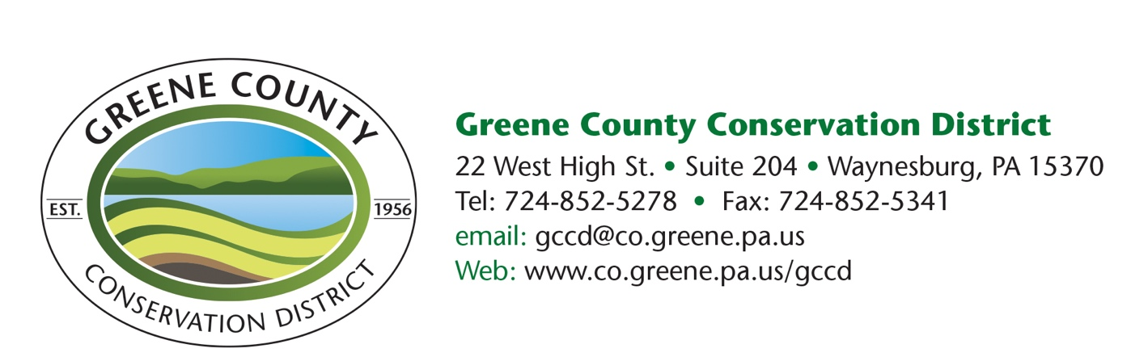

News Release
Conservation District offers cost share program
FOR RELEASE –
WAYNESBURG, PA – The Greene County Conservation District Board of Directors are currently accepting 2022 applications for the GRACE program. Greene County’s Reinvestment in Agriculture: Cost-share Enhancement (GRACE) Program is a conservation-based program designed to enhance soil health within the agriculture community.
The GRACE program provides guidance and financial assistance to farmers and forest landowners. Technical assistance and cost share practices are designed to promote soil and water conservation practices that will improve soil health in pastures and woodlands. These practices can lead to better animal production as well as, healthier soils and forest stands. When these practices are implemented correctly, value and profit can be added to the land. Practices include but are not limited to lime, fertilizer, fencing, watering systems and forestry practices.
“It is the goal of the district to offer a program that supports the mission of ensuring healthy soils for viable farming, while maintaining a program that is easy to navigate and has a quick turnaround,” Lisa Snider, district manager said.
GRACE does have some simple requirements. For example, anyone wishing to apply for GRACE must become a cooperator with the Conservation District. Also, if a landowner is interested in assistance with lime or fertilizer, they must obtain a soil test kit from Penn State Extension that Conservation District staff will administer during a farm visit. The District urges applicants to keep this in mind if they are planning on submitting an application, some time will be needed to conduct the farm visit and to get the information back needed for applications.
The final requirement is for appropriate farm conservation-based planning, that could include manure management plans at a minimum and in some cases conservation plans. The Conservation District will work with first-time applicants to offer assistance in plan development so that they may continue in the program. Returning applicants are required to have plans in place at the time of application. For forestry conservation practices, the landowner must have a forest management stewardship plan, American tree farm plan or CAP 106 plan in place at the time of application. The program can assist landowners with costs associated with forestry plan development.
Funds for the program are a direct result of PA Act 13 which the district receives annually to foster conservation efforts within Greene County. Snider emphasized, “these funds are obtained through an ‘impact’ fee and the district believes that the money received should be used on the ground where the impacts were made.”
Applications must be submitted by August 31. Application approvals are made in September by the GCCD Board and approved practices must be completed the following year by December 31.
For more information or to apply, call the District at 724-852-5278, e-mail gccd@co.greene.pa.us, or visit during office hours at 22 West High Street, Waynesburg. Office hours are Monday-Friday from 8:30 a.m. to 4:30 p.m. The application can also be found online at www.co.greene.pa.us/department-conservation-district.
# # #

