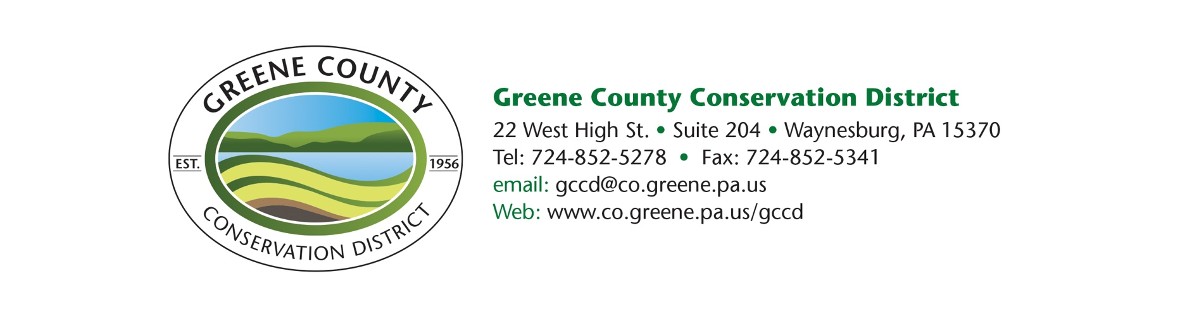

News Release
Contact: Lisa Snider
District Director
724-852-5278
lsnider@co.greene.pa.us

Conservation District honors two at annual awards ceremony

FOR RELEASE – Dec. 16, 2021

WAYNESBURG, PA – The Greene County Conservation District honored two recipients during its annual awards ceremony Wednesday, Dec. 15, at Valley View Farm.

Each year, the Conservation District honors those within the county who have shown an outstanding commitment to soil and water conservation. Honorees for 2021 included Gene Saurborn and Bobbi Bailey of Buckshot Cattle Company, recipients of the Outstanding Cooperator of the Year Award and Zachary Frye, recipient of the Outstanding Conservation FFA Speaking Award.

Gene Saurborn and Bobbie Bailey owners of the Buckshot Cattle Company located on Big Shannon Run Road, were honored as the 2021 Outstanding Cooperator of the Year. This award is given to local farms that have shown substantial improvements to their operations by committing to the use of conservation practices that are intended to improve soil and water quality.

Mr. Saurborn and Ms. Bailey’s farm is located in Perry and Whiteley Townships and is nestled within both the Dunkard and Whiteley Creek Watersheds. The 202-acre farm along with additional leased acreage supports a cow-calf operation that consists of mainly Simmental and Angus breeds and a few horses. The farming operation has implemented numerous federal, state and local programs and practices intended to improve soil and water quality. Their years of implementing farming practices that protect our natural resources were leading factors in being selected for this award.

Zachary Frye, a 2021 graduate of West Greene High School and November 2021 graduate of USMC Parris Island boot camp, was recognized for his outstanding speaking skills at the county speaking contest with his speech entitled “Energy: Preserve, not Replace”. During the 2021 speaking contest year, he advanced through the county and area rounds and placed first in the regional Conservation Speaking contest. This qualified Zachary for the State Prepared Speaking Contest making him the highest placing Conservation Speaker in the Greene County FFA programs. Frye is the son of Chris and Danielle Frye of Holbrook, and enlisted in the United States Marine Corps.

Outstanding Conservation FFA Speaking Award.jpg
[James A. Cowell, Jr., presented Chris and Danielle Frye, parents of Zachary Frye of Holbrook, the 2021 Outstanding Conservation FFA Speaking Award on behalf of Zachary at the Greene County Conservation District’s annual award ceremony on Wednesday, Dec. 15.]

Outstanding Cooperator of the Year Award.jpg
[James A. Cowell, Jr. presented Buckshot Cattle Co. owners Gene Saurborn and Bobbi Bailey with the 2021 Outstanding Cooperator of the Year Award at the Greene County Conservation District’s annual award ceremony on Wednesday, Dec. 15.]
# # #

