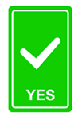
Greene County, PA
recycles only the following:

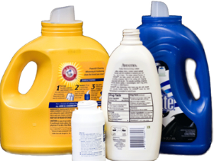
- Plastics must have recycling symbol 1 or 2.
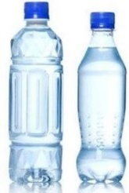
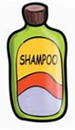

Plastic #1 bottles are usually water and drink bottles, some food packaging…
Plastic #2 bottles are usually milk, shampoo, hand lotion, pain medicine, vitamins,
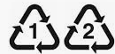
liquid soap, cleaning products…Look for the symbol.

- Clean Food/Drink cans no larger than 1 gallon
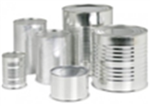
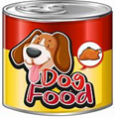
Rinse food out of cans!

- Cardboard, paper, newspaper, mail, office paper
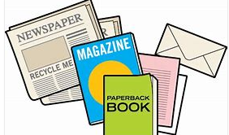
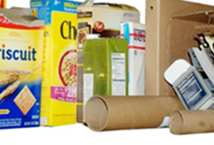
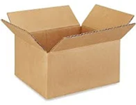

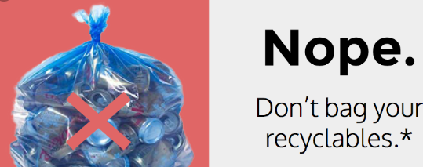
If it is not on this list, do not put it in the recycling.
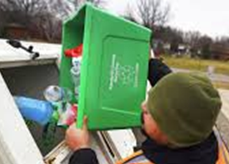
if you bring sorted recyclables in plastic gags, open the bag,
*Then just dump recyclables into the appropriate bins!
Consider using cardboard boxes, paper bags, or re-useable plastic totes.
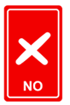
DON’T PUT THE FOLLOWING IN RECYCLING:
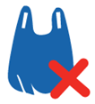
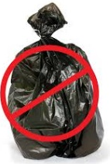
NO:
- Plastic bags (dump recyclables into the bin)
- Plastics with symbol 3-7
- Plastics without a recycling symbol
- Cans with food residue
- Glass
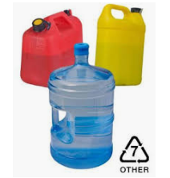
- Waxed milk cartons
- Styrofoam
- Garbage
- Furniture, mattresses…
- Cloth items
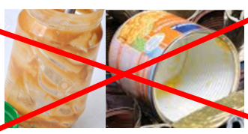
- Toys
- Scrap Metal or wire
- Construction waste, sinks, siding…
Many recycling collection sites have security cameras

DON’T PUT BAGGED ITEMS IN RECYCLING BINS!
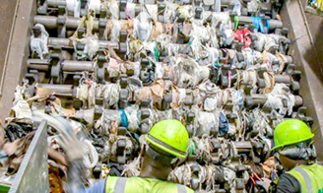
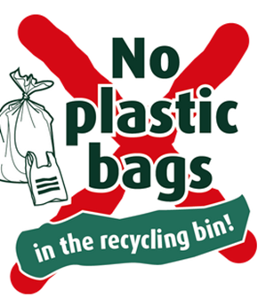
Open your bags and dump items into the correct bins.
Plastic bags get caught up in the equipment at recycling facilities, causing major jams and equipment problems.

